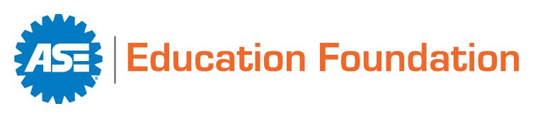
Memorandum of Understanding
Automotive Service Apprenticeship Program (ASAP)
This memorandum of understanding (“MOU”) defines the responsibilities that the ASE Education Foundation and _______________________________________________________ (“Business”) in _________________________ (City), ____ (State) acknowledge and agree are necessary to make the ASE Automotive Service Apprenticeship Program (ASAP) available to qualified automotive, truck/diesel, and/or collision repair students.

ASE EDUCATION FOUNDATION RESPONSIBILITIES
- Provide the ASE accreditation process for schools that wish to participate in the ASAP program.
- Provide schools with ASE Entry-Level and Professional Certification tests to assess their students’ academic achievement.
- Register the apprenticeship program with the federal Department of Labor and/or state agencies as needed and update the components of the program over time to remain current with changes in technology.
- Provide information, guidance, and assistance to increase awareness of the schools automotive, truck/diesel, and/or collision repair training programs and to promote the benefits of the ASAP program to students and employers.
- Provide guidance and assistance in engaging local employers to hire student apprenticeships.
- Provide resources and directions for implementing the ASAP program and training for business supervisors, mentor technicians, apprentices, and educators.
- Assist schools and employers in implementing the ASAP program through its network of Field Managers and industry contacts.
- Provide a mobile app to track apprentices’ progress.
- Provide the Department of Labor and other agencies with information on new apprentices and update records when apprentices complete or leave the program.
- Provide recognition materials for participating mentors, students, employers, and employers.
- Recognize apprentices who complete the ASAP program and provide a certificate to verify their accomplishment.

BUSINESS/EMPLOYER RESPONSIBILITIES
- Hold a current business license, carry appropriate liability insurance, provide a safe and welcoming workplace, and enforce all program rules regarding PPE and restricting job duties of apprentices.
- Follow all federal and state employment and workplace laws and regulations – EEOC, OSHA, DOL, etc.
- Promote the use of the ASE ASAP program with managers and staff.
- Develop job descriptions for Mentor Technicians and Apprentices.
- Sign the ASE Apprenticeship Program Appendix D (Dept. of Labor) and a Memorandum of Understanding (MOU) with the ASE Education Foundation, listing these same responsibilities.
- Actively participate in the employer’s Advisory Committee, providing guidance and support in such areas as facilities, equipment, and curriculum.
- Participate in activities that promote automotive service industry careers and the ASAP program such as guest speeches, career fairs, and shop tours.
- Provide non-paid job shadowing opportunities and interviews for qualified ASAP candidates.
- Work with school to identify employer/work schedules that are beneficial to the business, the employer, and the apprentice.
- Hire one or more apprentices that meet the ASAP program qualifications.
- Identify, train, and support one or more supervisors to direct the apprentices and mentors in the workplace, verify that apprentices are making progress based on activity that is tracked in the provided mobile app, and meet with employer staff to review apprentices’ progress on a regular basis.
- Identify, qualify, train, and support the participation of one or more experienced service technicians as mentors for apprentices.
- Allow the mentors selected for participation in the ASAP program, as well as their apprentice students, to attend a mandatory introductory one-day training session.
- Use the provided mobile app to track ASAP program apprentice progress.
- Identify cost-effective ways for apprentices to procure hand tools, uniforms and PPE as needed for the job.
- Pay the apprentice in accordance with the agreed-to schedule, provide a pay increase when the apprentice has successfully demonstrated the required competencies, and a second pay increase when the apprentice completes the apprenticeship if an offer of continued employment is made.
- Pay the ASE Education Foundation a one-time fee of $1,000 for each ASAP program apprentice to cover the cost of the mobile app, DOL reporting, and program coordination for 24 months.
SCHOOL RESPONSIBILITIES
- Obtain ASE Accreditation for their training program and continue to maintain all program standards, including Advisory Committee functions, instructor ASE certifications, and instructor technical update training.
- Measure the academic progress of students using assessments such as the ASE Entry-Level or Professional Certification tests.
- Promote the use of the ASAP program with administrators, staff, instructors, parents, and students.
- Provide opportunities for activities that promote automotive service industry careers and the ASAP program such as guest speeches, career fairs, and shop tours.
- Coordinate student participation in non-paid job shadowing opportunities and interviews for qualified apprenticeship candidates.
- Work with businesses to identify employer/work schedules that are beneficial to the business, the employer, and the apprentice.
- Provide guidance to local employers regarding child labor laws, work permits, and or other requirements related to student employment.
- Coordinate the ASAP program application process and matching of apprentices with employers.
- Provide mentor/mentee training for qualified ASAP program candidates.
- Provide a primary contact person to coordinate the ASAP program, oversee apprentices’ progress, and meet with business supervisors on a regular basis during the employer year and the summer.

The ASE Education Foundation and its educational and business partners acknowledge and accept that this agreement serves as the foundation for a successful Automotive Service Apprenticeship Program. Students, schools, employers, and industry all benefit when students are allowed the time to gain proficiency under the guidance of a qualified and caring mentor. This MOU is effective on the date of acceptance by the Employer/Business Owner or Manager identified in the signature section below. Such Employer/Business Owner or Manager warrants that he or she is authorized to so accept this agreement. Both ASE Education Foundation and the Employer may terminate this MOU for any reason by providing thirty (30) days written notice to the other party.
Acknowledged by:

______________________________________
Name of Business

______________________________________ ________________________
Address City, State, Zip

______________________________________ ________________________
Employer Owner/Manager signature Date

______________________________________ ________________________
Printed Name Title

______________________________________ ________________________
Email Phone Number
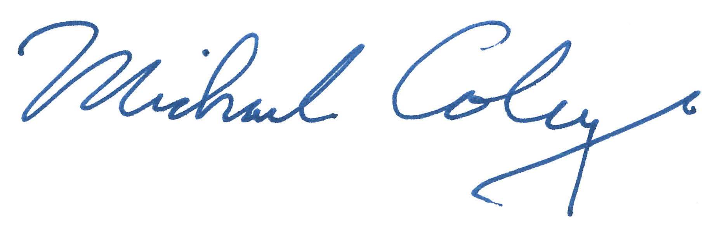

_____________________________________ __May 17, 2022____________
ASE Education Foundation signature Date

___Michael Coley ______________________ __President______________
Printed Name Title
ASE Education Foundation
101 Edwards Ferry Rd NE Ste 401, Leesburg, VA 20176
info@ASEeducationFoundation.org
(703) 669-6650
Website: www.ASEeducationFoundation.org

